CONNECTING TO THE BEST “SECURE-VPN and RICOH”
Originator: | Sender De La Roca | Revision Date: | June 05, 2025
Manager Approval: | Robert Bayles | Effective Date: | June 24, 2019
Reviewer: | Robert Bayles | Original Date: | June 24, 2019
PURPOSE
Procedures to connect to RICOH servers using BEST VPN
PROCEDURES

In order to connect to the LACOE BEST environment, you will need to use the LACOE BEST SSL VPN by performing the steps mentioned below.
If you experience errors, or have any concerns, please contact the LACOE HelpDesk by email: HelpDesk@lacoe.edu or call (562) 922-6646
- Click on either of the URL listed below.
  - https://dr1-vpn.best.lacoe.edu/best
  - https://vpn.best.lacoe.edu/best
  - Enter your best username and password
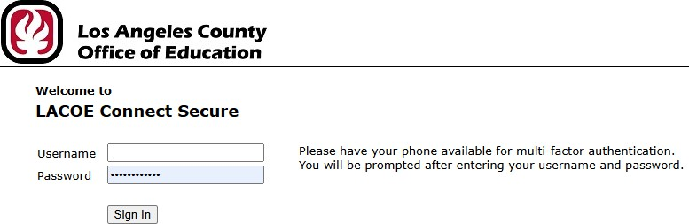

- If needed change your assigned password if logging on for the first time. Password must be at least 8 characters long
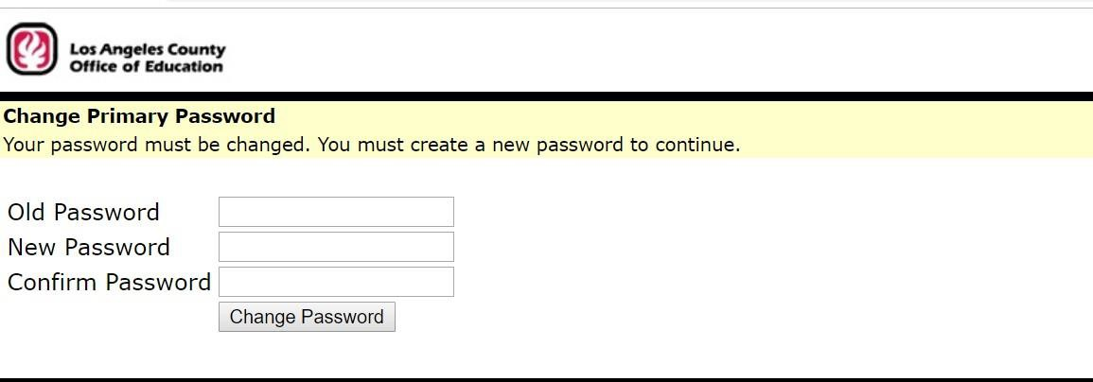
  - Enter your assigned password
  - Create new password
  - Confirm Password
  - Click Change Password

- You will be required to use MFA to continue. Request to authenticate will be sent to your device of choice.

- Once you passed MFA or you change your password, you will be able to login you will see the next page with these links below, Click on UAT RICOH for UAT or PRD for Production.
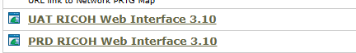

- At the RICOH sign in page, use the same ID and password you used to access the IVANTI page.
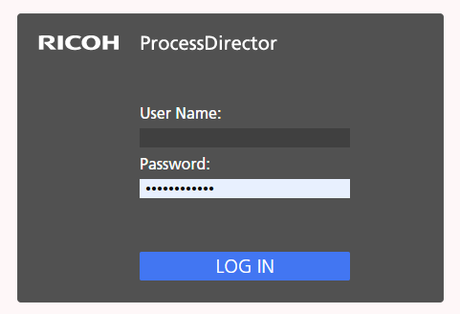
- Now you are in the RICOH BEST server.

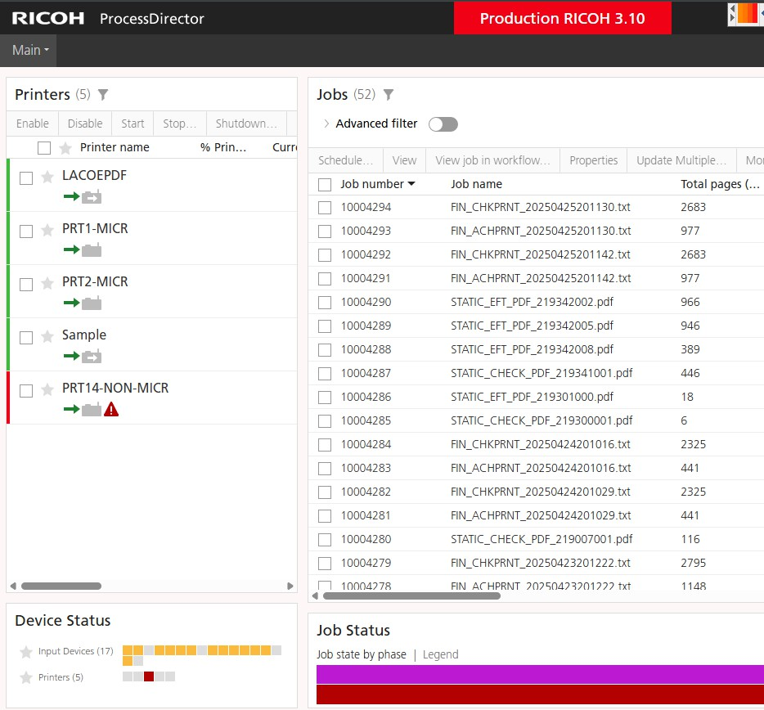

- Your session may look different from the one above.
- You are now ready to follow the procedures on how to print Warrants using RICOH server.

